How are absences deducted?
- Sick Leave is your main category balance. Any time taken as Sick Leave or Sick Leave-Personal Necessity is taken from available Sick Leave balances.
- Please note that only 7 days of available Sick Leave can be used as Sick Leave-Personal Necessity per school year. Out of these 7 days, 4 can be used as "No Tell".
- "No Tell" days should be entered as Sick Leave-Personal Necessity and enter "No Tell" in the notes.
- Please note, once Sick Leave balances are exhausted, Sick Leave-Personal Necessity becomes unavailable.
- Emergency Family Care and Bereavement are separate absence buckets and are not taken from Sick Leave.
- If you have any questions about absence category reasons please see the WEA Contract Article 12

How to check your leave absences balance?

STEP 1
- Log in to your Frontline (Aesop) account – the following screen will populate https://absenceadminweb.frontlineeducation.com/access
- You can create an absence and view your scheduled absences and past absences
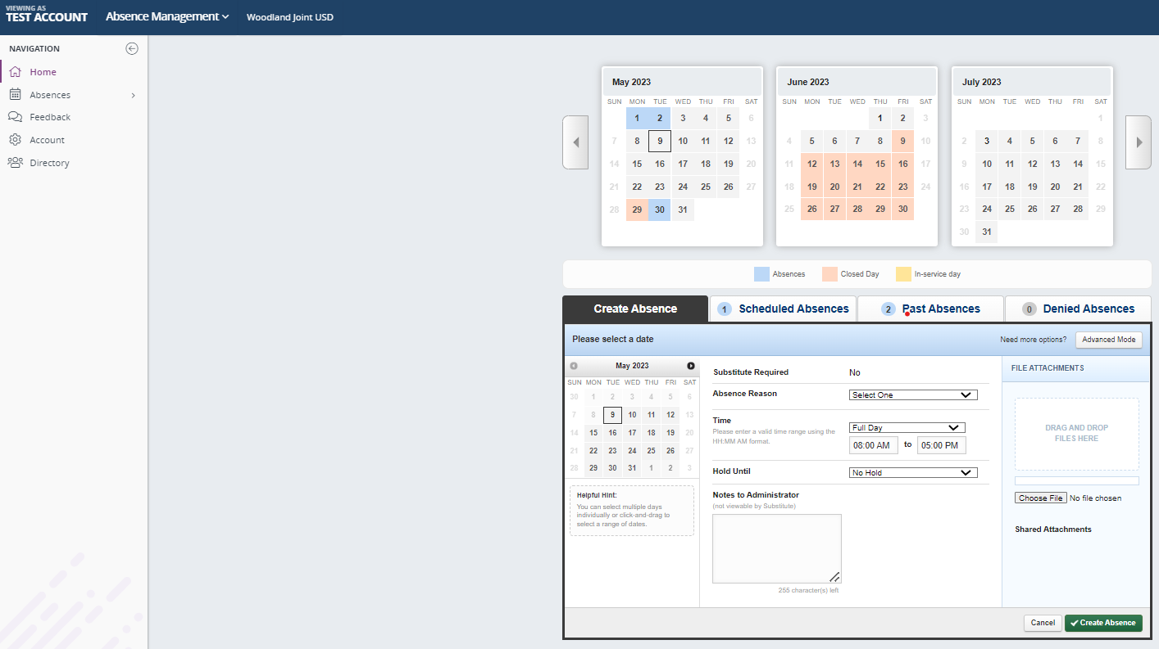
STEP 2
STEP 2
- Click on the Account icon as shown above

STEP 3
- The following screen will populate
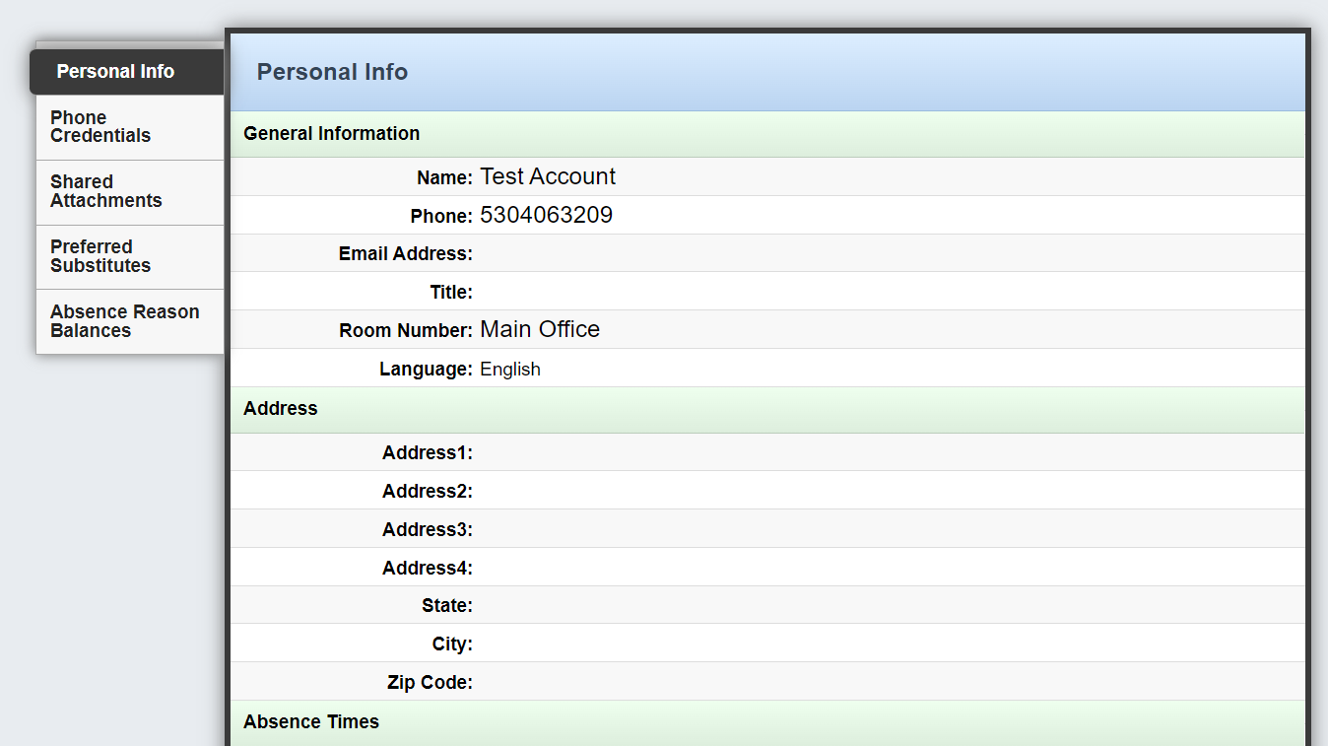
STEP 4

STEP 4
- Click on the absence reason balances icon to be able to view your UP TO DATE ABSENCE BALANCES
- Please note that only 7 days of available Sick Leave can be used as Sick Leave-Personal Necessity per school year. Out of these 7 days, 4 can be used as "No Tell".
- "No Tell" days should be entered as Sick Leave-Personal Necessity and enter "No Tell" in the notes.
- Please note, once Sick Leave balances are exhausted, Sick Leave-Personal Necessity becomes unavailable.
