How are absences deducted?
- Sick Leave is your main category balance. Any time taken as Sick Leave or Sick Leave-Personal Necessity/No Tell is taken from the available Sick Leave balances. Please note that only 7 days of available Sick Leave can be used as Sick Leave-Personal Necessity per school year. Out of these 7 days, 2 can be used as "No Tell". Any time taken as "No Tell" will need to be deducted from the overall Sick Leave-Personal Necessity balance. Frontline will only display your initial and taken balances.
- Once Sick Leave balances are exhausted, all other Sick Leave category balances become unavailable.
- Family Care and Bereavement are separate absence buckets and are not taken from Sick Leave.
- If you have any questions about absence category reasons please see CSEA Contract Article 14

STEP 1
- Log in to your Frontline (Aesop) account – the following screen will populate https://absenceadminweb.frontlineeducation.com/access
- You can create an absence and view your scheduled absences and past absences
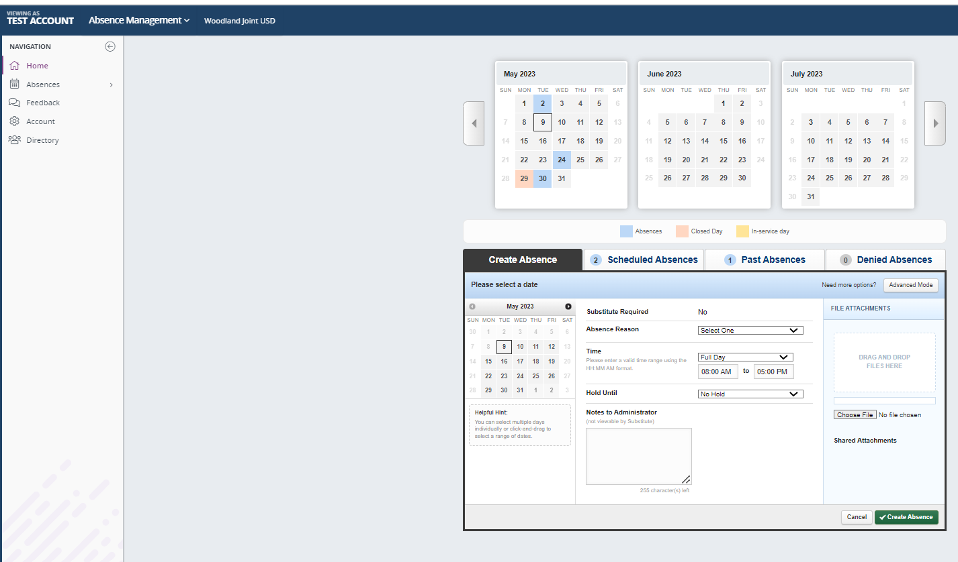
STEP 2
STEP 2
- Click on the Account icon as shown above

STEP 3
- The following screen will populate
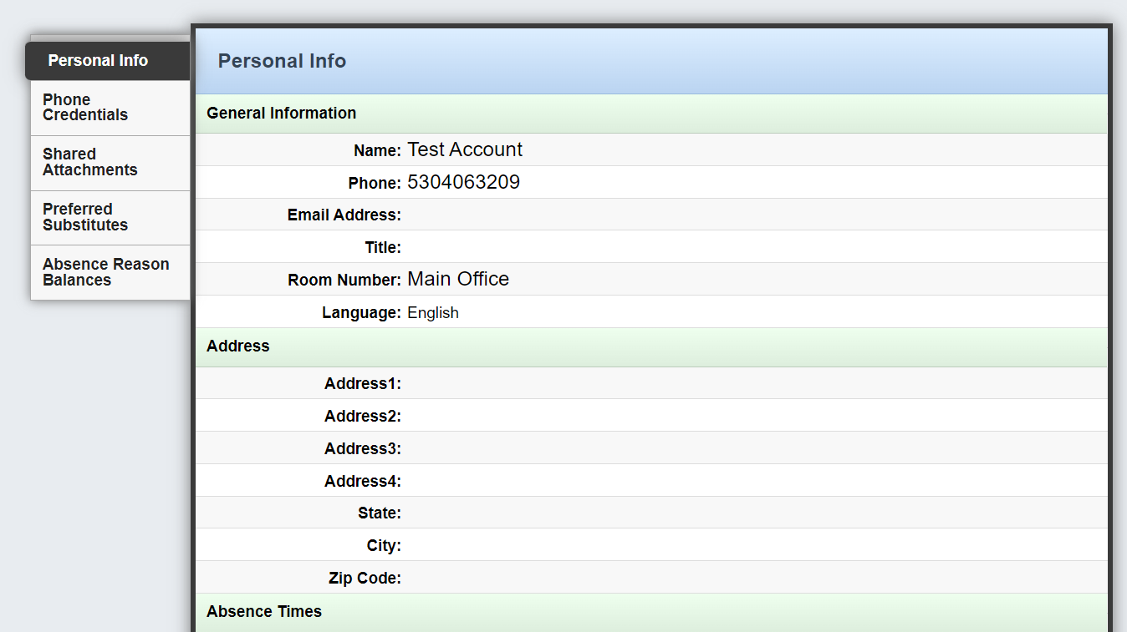
STEP 4

STEP 4
- Click on the absence reason balances to be able to view your available balances
- Once Sick Leave balances are exhausted, all other Sick Leave category balances become unavailable.
- Any time taken as "No Tell" will need to be deducted from the overall Sick Leave-Personal Necessity balance. In the example below, the employee has a balance of 48 hours but they have taken 4 hours of Sick leave-No Tell/PN; therefore, the remaining Sick Leave-Personal Necessity balance is 44 hours.
